Job Title: | Parent Carer Representative | Job Code: | SPCF- PR
Department: | SPCF | Travel required: | Yes (expenses paid)
Level/salary: | £14 per hour | Position Type: | Flexible hours (zero-hour contract)
HR Contact: | Ruth Hobbs | Date Posted: | 1st February 2022
Parent Carer Representative Purpose
Parent Carer Representatives play a vital role in the work of Somerset Parent Carer Forum CIC by promoting the voice and lived experiences of families in Somerset. They develop positive and constructive working relationships (with other parents and professionals) to find solutions to improve support and services.
The Parent Carer Representatives role is to represent the wider parent voice in all its complexity. Parent Carer Representatives are objective and focus on the collective view of parents, putting their own personal circumstances or situation to one side.
Reports to
Parent Carer Representatives report to the directors. Each representative will be offered an induction, ongoing supervision, and support.
Main Tasks, Duties and Responsibilites
The role of a Parent Carer Representative can be varied so flexibility is essential. The following represents the range of tasks, duties and responsibilities you may undertake within this role.
- Promote the involvement of parent carers and champion parent voice
- Attend meetings with service providers to share the experience collected
- Work on projects to shape resources including training modules, leaflets, websites
- Work on service redesign projects to ensure they meet local needs based on feedback
- Contribute to the collection of feedback and experiences of families.
- Work as part of the team to organise and run events and training.
- Completing a report for each meeting, workstream or event attended
Additional opportunities
Parent Carer Representatives are often given the opportunity to get involved in specific project work. These projects are allocated on a case-by-case basis by the directors and the rates of pay may vary.

Training requirements
All Parent Carer Representatives will undertake an induction programme. This will be scheduled around the individuals’ circumstances. The induction will include but not be limited to:
- Understanding Co-production
- Role of a forum and parent rep including how to contribute effectively to strategic work
- Forum governance and policies
- Safeguarding policy
- Basic understanding of SEND and SEND law
Organisational Position
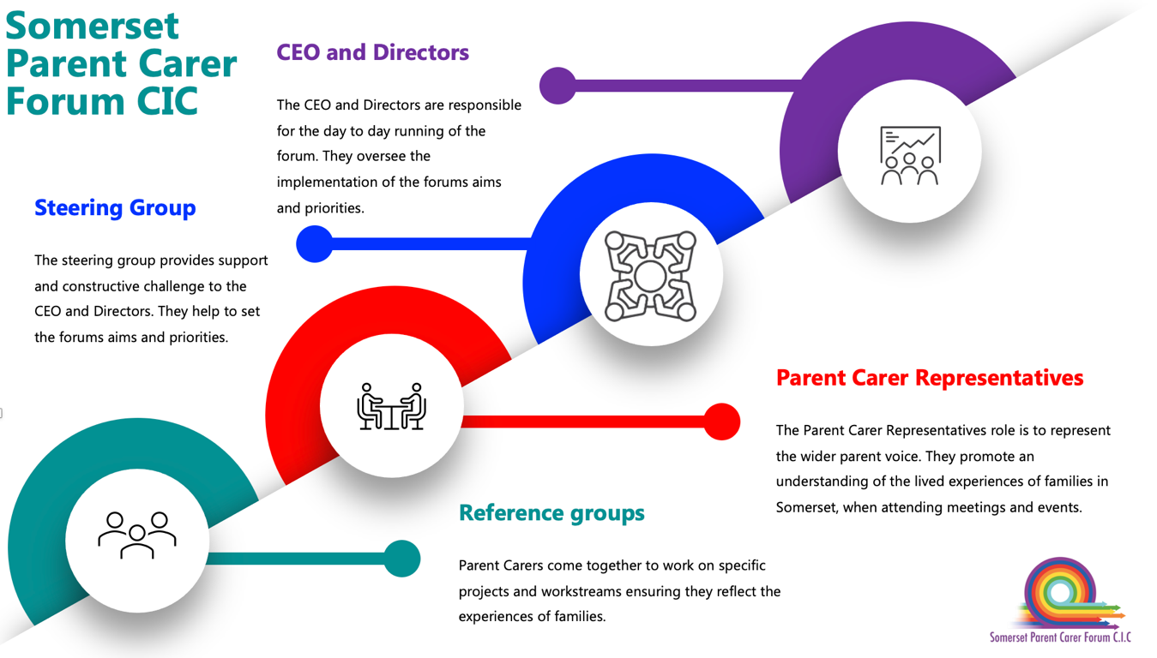

Other relevant information
- Hours are arranged with each individual Parent Carer Representative to fit around their personal circumstances. We cannot guarantee a fixed amount of hours.
- Payment for meetings is dependent of completing a brief report/feedback form (help is available to do this).
- Depending on work undertaken a DBS may be required (SPCF will cover the costs of this)
- SPCF work on a blended approach of online and face to face meetings. Travel maybe be required to venues throughout Somerset.
- All Parent Carer Representatives will need to abide by the forums policies and sign the code of conduct.

