
Children’s Voice Resource Pack
This pack contains resources as signposted in the Explanatory Note for Schools which you may find useful in order to seek children’s feedback, to inform the completion of the Children’s Voice Self-Assessment Tool. These are suggestions for activities and are not exhaustive. If you already have resources within your school which would better suit the needs of your children, please do use those. We encourage flexibility and creativity to maximise engagement with children. The table below lists the resources available in this pack, some instructions on how you may wish to use these, and the page within this pack the full resource or an example can be found.
We would like to thank Derby City Council and their children and young people, for contributing to some of the resources contained in this pack.
Resource | Instructions | Page(s)
My Feelings About School questionnaire | - This resource can help children to reflect on their experience of school.  - It can be used by an adult with a group of children, or children could complete this on an individual basis.  - Provide each child with a questionnaire; read out each statement and ask the children to tick their selected response (yes, sometimes, no). Give children time to add in any ideas that they have that would make things better for them in school.  - Encourage the children to be as honest as they can, thinking for themselves. There are no right or wrong answers and teachers want to hear what children like and would like to change about their school.  - For a Microsoft Form online template version of this questionnaire, please use the following link: https://forms.office.com/Pages/ShareFormPage.aspx?id=yXfS-grGoU2187O4s0qC-anjwjrEYo5PrOi4FUdtU39UMFg4T1AwSVoxUk5HRTVBNDhITjg4MDMwNC4u&sharetoken=uA5R4gjWtHyD7qhPLcpz  - After accessing the above link, you may choose to send this to pupils or parents via email to complete an online version of the questionnaire. This could be emailed to pupils currently attending school to complete online during the school day, or to pupils or parents of pupils of children who are not currently attending school to complete at home.  - All responses will be returned to the sender of the link and should then be collated and reflected in the Children’s Voice Self-Assessment Tool along with feedback from any of the other resources or methods chosen. | 3
‘Getting to Know Me: Three Things’ | - This resource might be particularly useful for adult-facilitated discussions with visually impaired children.  - On the dotted line under the heading, the facilitating adult can input which of the domains from the Children’s Voices Self-Assessment Tool this is responding to. For example, if responding to ‘Communication’, the adult can ask the child for 3 things they like, don’t like, would change, and would want to stay the same.  - The adult should record the child’s responses, using the child’s choice of words, against the three numbers. | 4
Magic Wand | - The ‘Magic Wand’ can also be applied to any of the domains set out in the Children’s Voice Self-Assessment Tool, and is suited for individual children, as well as pairs or small groups – either working independently or collaboratively.  - children could use this space to create a characterised version of themselves as a wizard to visually display their thoughts.  - Alternatively, children may wish to fill this page with words or ‘spells’ that explain what they would change. | 5
Walk around | - A school walk-around, with a facilitating adult, could be a useful way to understand the child’s emotions and points of interest. The child can highlight things they do/do not like and how different aspects of the school make them feel.  - The child may complete the attached ‘treasure map’ template, filling in areas of the school they wish to visit (either with words or pictures) on the tour which will guide the discussion (or this can be completed without a map). | 6  (for map template)
Augmentative and alternative communication methods | - For some children, augmentative and alternative communication methods might be a useful way to collect their views. Some examples may include pictures, communication books, sign language, body movements and gestures. However, this list is not exhaustive.  - We encourage you to work with your local system partners to identify resources which could be useful.  - In addition to resources, your local partners might be able to provide some ‘top tips’ when gathering views in this way – for example, that using emojis/emoticons or faces with expressions is not suitable for all neurodiverse children, or those with special educational needs and disabilities. | N/A
‘Listen to Me Post-It’ exercise | - This exercise could be used individually or in groups, as a written or visual (using the talking cards) activity. children could cluster their thoughts/feelings written on the post it notes around themes on a whiteboard/piece of paper.  - This activity could be combined with the child creating a model, picture, or portrait, or using the resources and methods for augmentative and alternative communication suggested above. We recommend adapting the questions to suit your children and be curious.  - An electronic version could also be created for the child to complete using a laptop or an adult could scribe responses. Text to speech software could also be used so that the sentence prompts are read out to the child without needing the support of an adult. | 7

My feelings about school
Question | Yes | Sometimes | No | It would make my school better if….
I feel safe and cared for at school.
I enjoy school clubs and activities and go on school trips.
My teachers listen to my views and ideas to make school better.
I have friends at school.
I enjoy being at school.
I feel happy at mealtimes and eat enough at school.

I know who to talk to if I feel worried, upset, or angry at school.
I can ask my teachers and they will help me with my work.
I learn a lot in lessons.
I feel proud of my achievements at school.

I like being in my school building.
I like my classroom.
I enjoy being in the playground or another place to play.
I get help to sort out any problems with my friends.

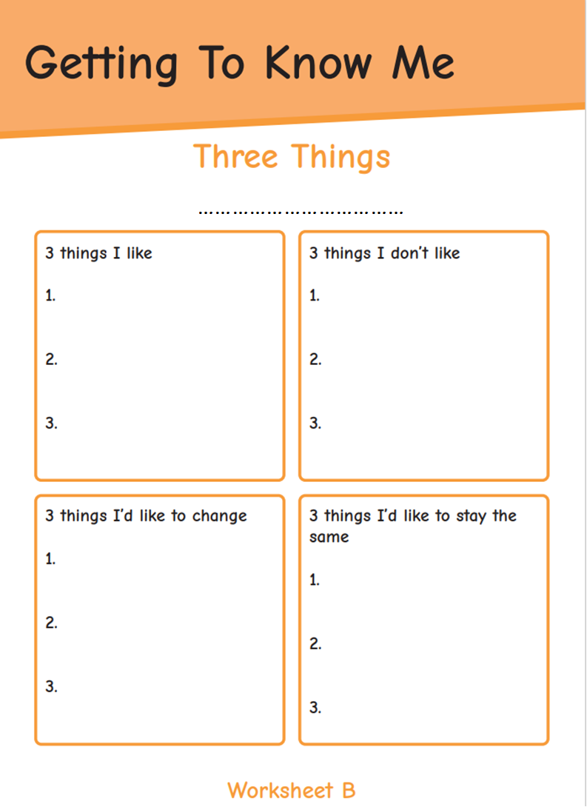
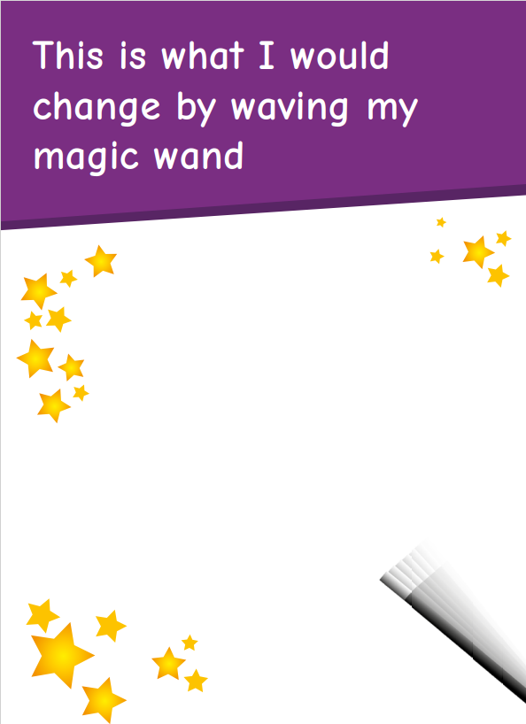

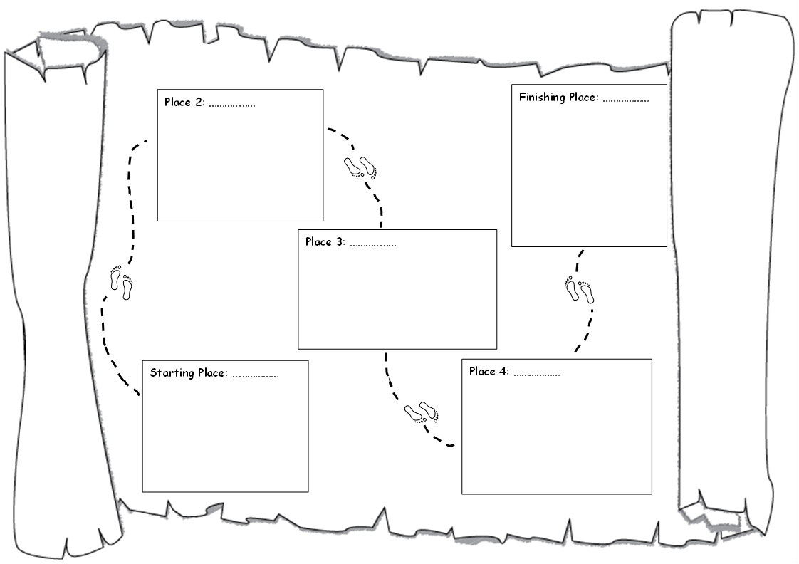
Things that are a little problem for me…
Things that are not a problem for me…
Things that are a big problem for me…
My teachers help me with…
Things I enjoy learning at school…
My favourite part of the school day is…
Things that I am good at…
My school friends help me with…

